1. **Agenda**:
   1. How to make dynamic response using the Response Templating Concept by reading the HTTP Request Body.
2. 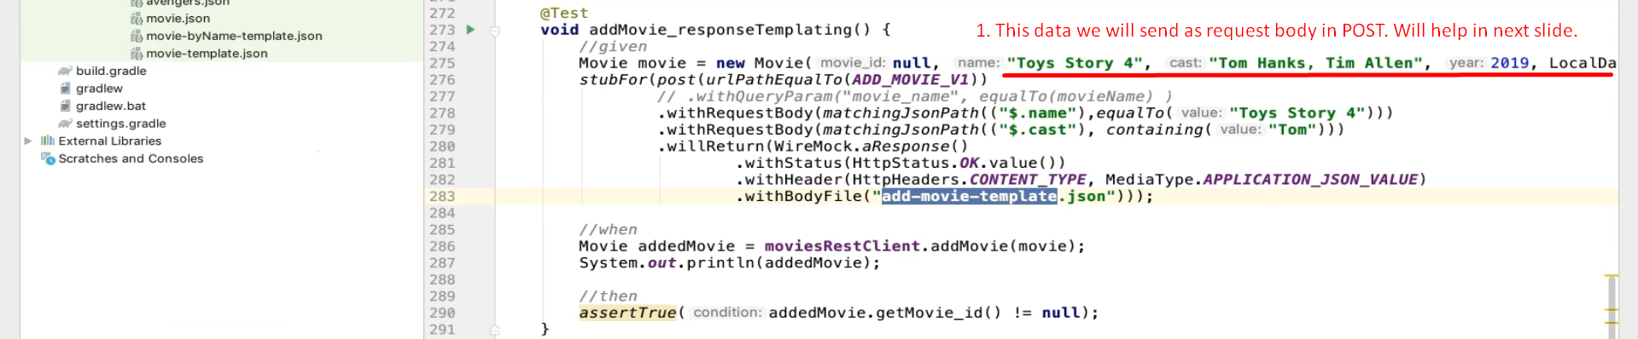
3. **Template Overview**

This template dynamically generates a JSON response using data from the request body and some random or formatted values. It leverages Handlebars templating syntax supported by WireMock's ResponseTemplateTransformer.

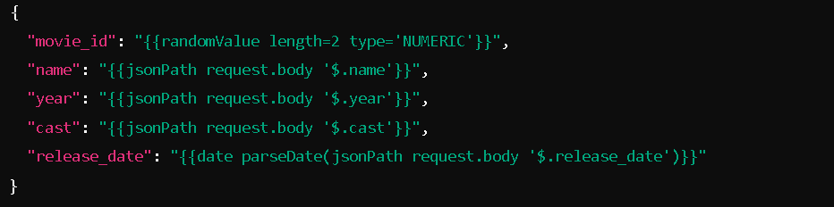  
  
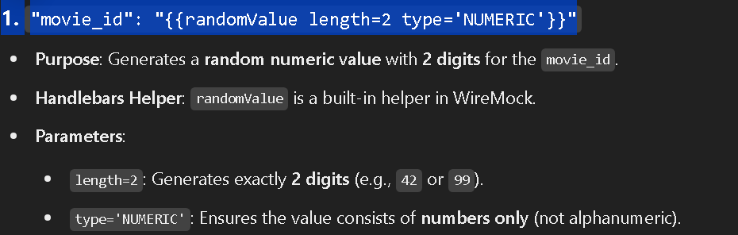  
  
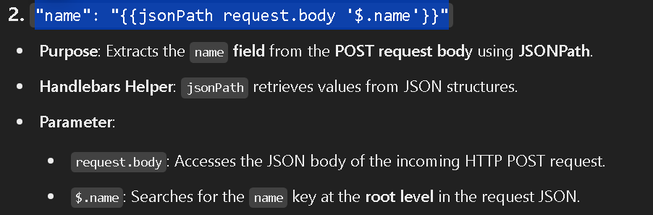

1. 